Hoe geef ik line numbers weer.

Klik op ‘Tools’ en vervolgens op ‘Options’

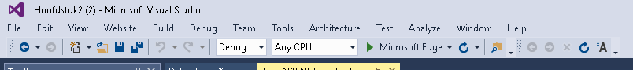

Klik naderhand op het pijltje bij ‘Tekst editor’

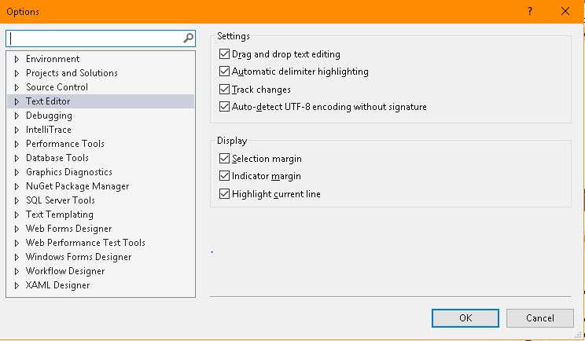Ga vervolgens naar ‘All Languages’ en daarna naar ‘General’

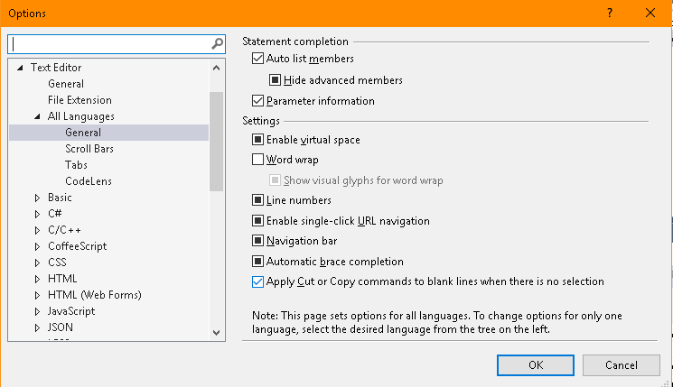

1.2

Hoe verander je de opslaglocatie?

Klik op ‘Tools’ en vervolgens op ‘Options’



Klik mettertijd op ‘Projects and Solutions’

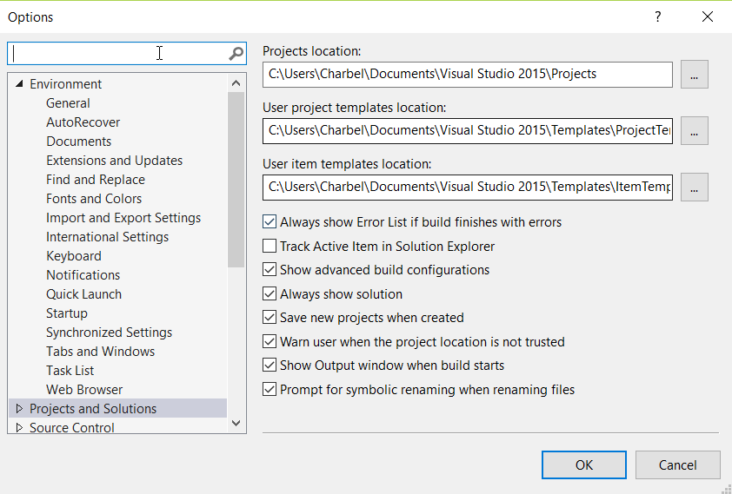

Op deze pagina kan je je source locatie veranderen

Opdracht 1.3

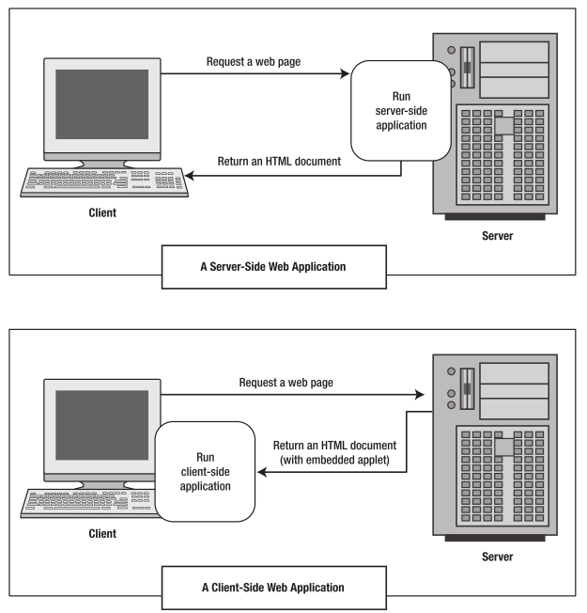

Server-side web Application:

De server is verantwoordelijk voor het leveren van de pagina

-ASP  
-python

De client vraagt de pagina op doormiddel van een web browser.

* Html
* Css
* Javascript

Opdracht 1.4

While PHP and Visual Basic .NET have similar language constructs, they are very different syntax for them. Since Visual Basic .NET is built upon an OOP model, variable declaration is much more rigorous than in PHP where a variable is declared simply by adding a dollar sign ($) before the variable name.

In Visual Basic .NET you declare a variable by specifying its name and characteristics. The declaration statement for variables is the Dim keyword. Its location and contents determine the variable's characteristics. Variables have levels such as local and module, data types, lifetimes and finally accessibility.

While this approach may seem more complex at first than variable assignment in PHP it actually makes a developer's life easier. ASP.NET focuses on helping developers build robust applications—and specifying data types makes tasks such as variable clean up, debugging, exception and error handling, and code maintenance much easier.

Source:

https://msdn.microsoft.com/en-us/library/aa479002.aspx

